College of Vocational Education,
Future Technologies,
AD006 - Associate Degree in Information Technology
INTE2507- Virtualization

Document Author: Vu Nguyen
StudentID: s4010423
Client: Akila Jayasooriya

Table of contents
1. Executive Summary
2. What is Virtualisation
2.1 What are the benefits implementing Virtualisation Technology
2.2 What are the downsides of implementing Virtualisation technology?
3. The Implementation of Virtualisation Technology to the environment
3.1 Hyper-V
3.2 ESXi
3.3 Choosing a Hypervisor
4. IT Infrastructure and solutions
4.1 Physical IT Infrastructure
4.2 Solutions Proposal
4.3 Topology Diagrams of propose solutions
4.3.1 Diagrams 1
4.3.2 Diagrams 2
5. Summary of Proposed Solutions
6. Reference

- Executive Summary
This document aims to provide a comprehensive virtualization solution for the college to create a flexible, scalable IT environment that can support the projected growth in students and staff numbers over the next five years. The proposed solutions focus on enhancing the existing infrastructure to minimise potential faults, improve operational resilience, and ensure a seamless user experience for both students and staff. By leveraging advanced virtualization technologies, the college can reduce physical hardware dependency, optimise resource allocation, and maintain high levels of performance while addressing current and future needs.
To achieve these goals, the document presents two potential solutions, each designed to prevent bottlenecks, optimise storage and network resources, and ensure high availability in the event of hardware failures. These solutions will address both immediate infrastructure limitations and anticipated challenges, thereby establishing a robust and fault-tolerant system that can adapt to the college’s evolving requirements. Through thoughtful design and strategic technology implementation, this proposal provides a proactive approach to creating a sustainable and flexible IT environment for the college.

- What is Virtualisation?
Virtualization is a technology that allows one physical computer to run multiple "virtual" computers, each acting as if it's a separate machine. Instead of having one computer do one job, virtualization lets that same computer do many jobs at once by creating virtual versions of servers, storage, or networks. Each virtual machine can run its own applications and operating system, sharing the physical computer’s resources like memory and processing power. This approach makes it easier to manage, control, and use computing power more efficiently, as everything runs from one central system.

2.1 What are the benefits of implementing Virtualisation technology?

By implementing Virtualisation technology into the system, it will benefit the clients in that:

- Cost-save: Investing in Virtualisation technology mean that the client will not need to invest more money into physical hardwares, and powers for maintenance

- Simple scalability and flexibility: With the implementation of virtualisation, the client will be able to add or remove resources as needed based on the current situation. New Virtual Machines (VMs) can be quickly added on demand, which favour a growing environment.

- Improved Disaster Recovery and Backup: Virtual machines are easier to back up and replicate, which helps with disaster recovery. In the event of hardware failure, VMs can be restored or moved to other servers with minimal downtime.

2.2 What are the downsides of implementing Virtualisation technology?
While Virtualisation is a great addition to the system, there are a few downsides that the client need to take into consideration:

- Single point failure: Since the default setup for hosting VMs requires only one singular physical server. It is at risk that if the physical server become faulty, it will affect the availability of a wide range of VMs

- Security Risks: Virtual environments can create additional security challenges. Misconfigurations, unauthorised VM creation, and virtual network vulnerabilities can expose the system to attacks if not properly managed and secured.

- Initial Setup and Hardware Costs: Implementing virtualization often requires powerful servers and specialised software, which can involve significant initial costs. Upgrading existing infrastructure to support virtualization may also add expenses.

- The Implementation of Virtualisation Technology to the environment
There are two possible Virtualisation technologies that the client can take into consideration, which are ESXi that are powered by VMware. And Hyper-V that is powered by Microsoft. While both are Type 1 Hypervisors, they both come with their own individual perks and downsides.

3.1 Hyper-V
Hyper-V typically lean on on the user friendly side, giving the user a graphical interface to work with. It can also be noted that one of its biggest advantages that separate itself from the competitors is its cost. Hyper-V is included with Windows Server at no additional cost, making it highly cost-effective for organisations already using Windows Server. Making it a budget-friendly option

However, in larger environments, Hyper-V has notable limitations. While it scales well for mid-sized environments (typically fewer than a thousand employees), it tends to underperform in high-density or highly complex setups. For these reasons, Hyper-V may not be the best choice for large enterprises or environments with very high resource demands.

3.2 ESXi
ESXi, created by VMware, is a powerful virtualization option that works well in large, complex environments. It offers advanced features like moving virtual machines between servers without downtime and balancing resources automatically, which helps keep everything running smoothly. ESXi can support a lot of virtual machines, making it a strong choice for big companies with high demands.

On the downside, ESXi can be more expensive. VMware charges for licences and tools to manage it, which might be too costly for smaller budgets. However, for organisations that need strong performance and reliability, ESXi’s extra features can be worth the investment.

3.3 Choosing a Hypervisor
Considering the college currently hosts around 2,000 people, including 1,800 students and over 200 staff, with a projected 25% to 30% increase in students over the next five years, choosing ESXi as the primary hypervisor would be an ideal solution. While ESXi involves a financial investment, it offers robust scalability and performance, which will help prevent bottlenecks and ensure smooth operation of virtual machines as demand grows.

- IT Infrastructure and solutions
4.1 Physical IT Infrastructure

Storage
- Synology RS129+ NAS:
  - 8-bay rack-mounted NAS located in the server room.
  - Contains 10 hard drives, each with 10TB capacity, totaling 100TB of storage.
  - Currently 80% full, meaning approximately 20TB remains available.

Networking
- Cisco 2901 Routers (10 units):
  - Supports secure data, voice, and video applications.
  - Includes Power over Ethernet (PoE) capabilities for powering network devices.
- Cisco 2960 Switches (20 units):
  - Each switch has 24 ports and operates at 100 Mb/s with two 1 Gbps uplinks.
  - Configured with four VLANs: one for students, one for staff, one for administrators, and one for BYOD (Bring Your Own Device).
  - These switches are approximately 10 years old.
- Cisco AS5506-X Firewall:
  - Offers IP filtering, URL filtering, DNS threat intelligence, and tracking.
  - Provides security features to protect network traffic and data.
- Cisco Catalyst 3560 Switches (3 units):
  - Each switch has 24 ports and is used for wireless applications.
- Cisco Aironet 1260 Access Points (10 units):
  - Wireless access points distributed across the campus to provide wireless network access.
  - Covers the school grounds for student, staff, and BYOD connectivity.
- Cisco 5508 Wireless LAN Controller:
  - Manages the Cisco Aironet access points, providing centralised wireless network control.

4.2 Solutions Proposal
With the anticipated growth in the student population, a key concern is ensuring continuous accessibility and availability of services, alongside accommodating the increased demand for storage. As student numbers grow, so does the risk of slower network traffic, reduced accessibility to essential services, and potential storage bottlenecks.

To address these potential issues proactively, it would be ideal to focus on storage and network virtualization now. Prioritising these areas will help prevent performance bottlenecks and ensure reliable access to services, effectively supporting the college’s needs over the next five years.

4.3 Topology Diagrams of propose solutions
Considering the resources the college can provide, including the switches, NAS, server, the service, and the computers. Here are some of the topology diagrams of the proposed solutions along with the listing of the devices for each diagrams

4.3.1 Diagrams 1

Device | Quantity | Estimated Cost | Total Cost
ESXi Server with RAID Controller | 1 | $7000 | $7000
Raid Hard Drives (16 TB each) | 20 | $450 | $9000
Network Interface Cards (NICs) | 12 | $200 | $2400
Expansion Unit for ESXI (12) | 1 | $1500 | $1500

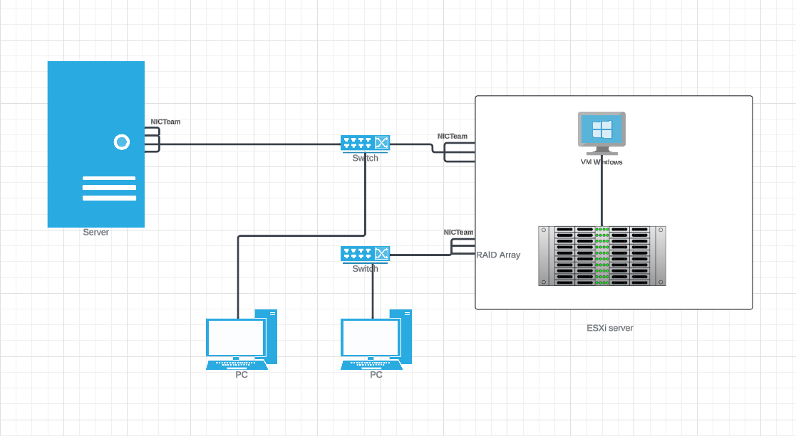

The concept behind this diagram is to ensure continuity and fault tolerance within the network infrastructure. Two groups of PCs are each connected to separate switches, both of which are connected to the ESXi server. One of the switches is also connected to a server providing services, configured with NIC teaming. This setup is designed so that if one PC or one group of PCs experiences a failure, users can still access the ESXi server through the other PCs instead. Additionally, if one of the NICs in the NIC team becomes faulty, the other NICs will take over, maintaining the connection. Within the ESXi server, a RAID array will host 320 TB of storage, providing sufficient capacity to prevent potential bottlenecks over the next five years.

4.3.2 Diagrams 2
Device | Quantity | Estimated Cost | Total Cost
ESXi Server | 2 | $5000 | $10000
NAS Server | 1 | $4000 | $4000
Raid Hard Drives (16 TB each) | 20 | $450 | $9000
Network Interface Cards (NICs) | 12 | $200 | $2400
Expansion Unit for NAS (12) | 1 | $1500 | $1500
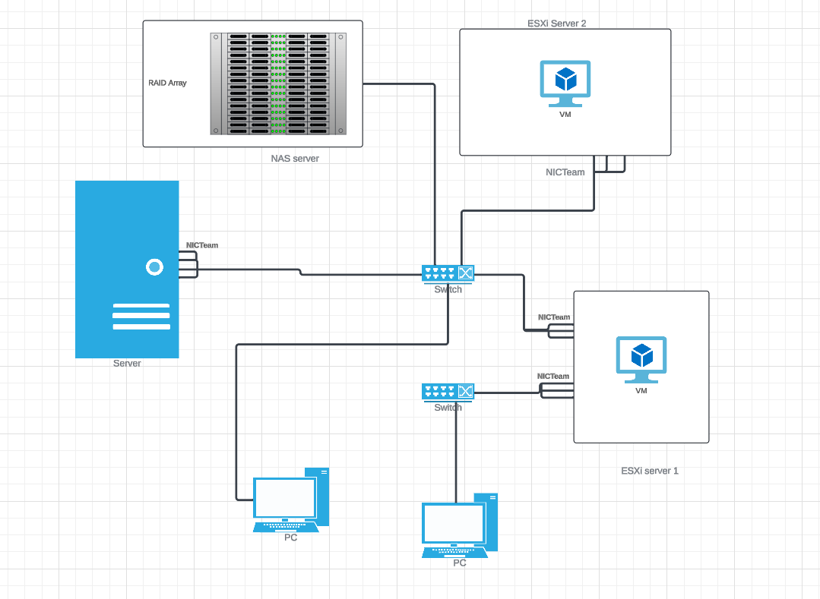
For the second diagram, This diagram consists of two groups of PCs, two switches, one server, two ESXi servers, and a pre-existing NAS. The NAS and the ESXi servers are configured with RAID, connected using the iSCSI protocol, allowing them to act as a single shared storage drive. The concept behind this setup is to ensure fault tolerance: if one of the ESXi servers becomes faulty, the data remains accessible and can still be used by the other ESXi server. This setup provides redundancy, enabling continuous access to critical data and minimising downtime.

5. Summary of Proposed Solutions
In summary the report is a comprehensive observation of the IT Infrastructure of the secondary college. The current college hosts about 1800 students, combined with 200 staff, with the prediction that the colleges will grow up to 25% to 30% and a growing trend of remote learning. Some adjustments were needed to accompany the growth of the college, and the implementation of Virtualisation technology.

Many pieces of technology are brought up for comparison such as Hyper-V powered by Microsoft, or ESXi powered by VMWare. However with the growth of the college, ESXi are considered to be a more viable choice for the future of the college.

In the end, two solutions were developed with the first solution focusing on increasing fault tolerance. By implementing in many points of connections, and introducing in NICTeams as the main focus of the solutions for mitigating any availability problem.

The second solution focuses on preserving the data while still maintaining a flow of traffic within the network with two ESXi servers. One acting as a main and the other acting as a fail save. Ensuring that the system won’t be disrupted.

6.Reference
vmware. (2019, December 12). ESXi | Bare Metal Hypervisor | VMware. VMware. https://www.vmware.com/products/esxi-and-esx.html

scooley. (2024, July 30). Hyper-V on Windows. Microsoft.com. https://docs.microsoft.com/en-us/virtualization/hyper-v-on-windows

VMware Vs. Hyper-V: Which Hypervisor Should I Use? (n.d.). CBT Nuggets. https://www.cbtnuggets.com/blog/technology/system-admin/vmware-vs-hyper-v-which-hypervisor-should-i-use

Microsoft (2024). Hyper-V Technology Overview. [online] Microsoft.com. Available at: https://learn.microsoft.com/en-us/windows-server/virtualization/hyper-v/hyper-v-overview

Reed, J. (2019). Hyper-V vs VMware: Complete Comparison of Platforms. [online] Official NAKIVO Blog. Available at: https://www.nakivo.com/blog/hyper-v-vmware-complete-comparison/.

Wikipedia. (2020). VMware ESXi. [online] Available at: https://en.wikipedia.org/wiki/VMware_ESXi.
Amazon.com.au. (2024). Seagate Exos X18 Serial ATA III 16000 GB Internal Hard Drive, 3.5 Inch Size: Internal Hard Drives: Amazon.com.au. [online] Available at: https://www.amazon.com.au/Seagate-Enterprise-Hyperscale-7200RPM-Improved/dp/B08JV7N6J1?source=ps-sl-shoppingads-lpcontext&ref_=fplfs&smid=A3P6X2GIMA114Z&th=1

MediaForm AU. (2024). Synology RackStation RS2423+ 12-Bay 3.5" Diskless 2xGbE NAS+ 1 x 10GbE (RJ45) (2U Rack) (SMB), AMD RyzenTM, 8GB RAM. Ask for a Solutions Project Quote. [online] Available at: https://www.mediaform.com.au/synology-rackstation-rs2423-12-bay-3-5-quot-diskless-2xgbe-nas-1-x-10gbe-rj45-2u-rack-smb-amd-ryzentm-8gb-ram-ask-for-a-solutions-project-quote/

‌

